# [Stabler addresses 'SVU' exit in new promo: 'I know I didn't handle that well'](https://www.today.com/popculture/elliot-stabler-addresses-svu-exit-new-promo-trailer-t211665)

Time for a little mea-culpa'ing, we think!

March 12, 2021, 3:50 PM -03 / Source: TODAY

By Randee Dawn

"Law & Order: SVU" fans know that Elliot Stabler has got some 'splaining to do.

Fãs de "Law & Order: SVU" que Elliot Stabler tem algumas explicações a fazer.

Nearly 10 years ago, when he left the show after season 12, Stabler's last scenes ended up being part of a cliffhanger, and his longtime partner, Olivia Benson, was briefly informed of his retirement in the first episode of the next season.

[Stabler aborda a saída ‘SVU’ em nova promo: ‘Eu sei que não lidei bem com isso.’](https://www.today.com/popculture/elliot-stabler-addresses-svu-exit-new-promo-trailer-t211665)

Tempo para um pouco mea-culpa’ing, nós pensamos!

March 12, 2021, 3:50 PM -03 / Source: TODAY

By Randee Dawn

Aproximadamente 10 anos atrás, quando ele deixou o show depois da temporada 12, últimas cenas de Stabler terminou sendo parte de um cliffhanger, e se sua parceira de longa data, Olívia Benson, foi brevemente informada de sua aposentadoria no primeiro episódio da próxima temporada.

Fortunately, Stabler — who is making fans happy by returning in his own spinoff, ["Law & Order: Organized Crime,"](https://www.today.com/popculture/stabler-s-coming-home-new-law-order-spinoff-teaser-completely-t209518) on April 1 — seems to know he's got some mea culpa'ing to do.

Felizmente, Stabler – que está fazendo os fãs felizes por retornando em seu próprio spinoff, ["Law & Order: Organized Crime,"](https://www.today.com/popculture/stabler-s-coming-home-new-law-order-spinoff-teaser-completely-t209518) em 1º de abril -

The former "SVU" detective offered viewers an explanation for his abrupt departure from the force [in a promo](https://www.instagram.com/p/CMUj6ZYg0Fd/) released Friday by NBC.

*Watch* [*TODAY All Day*](https://www.today.com/allday?icid=ed_npd_td_to_tad_200717)*! Get the best news, information and inspiration from TODAY, all day long.*

[Law & Order no Instagram: “Stabler was always looking for the right moment. #OrganizedCrime”](https://www.instagram.com/p/CMUj6ZYg0Fd/?utm_source=ig_embed)

"Stabler was always looking for the right moment," the caption reads.

Now, anyone paying close attention will know that this is not an entirely *new* trailer. A shorter version of it [popped up on Instagram in February](https://www.today.com/popculture/stabler-s-coming-home-new-law-order-spinoff-teaser-completely-t209518), giving everyone their first real glimpse as to what Christopher Meloni, who originated the character in 1999, will look like in the "SVU" spinoff.

But this time, he's got a little bit more to say, and now we know who he's talking to: Odafin Tutuola (Ice-T). And Fin has a few choice words to fire back.

**Related:**

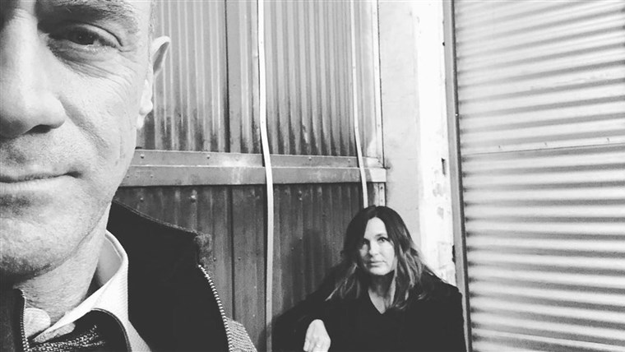

## [Mariska Hargitay and Chris Meloni reunite for new episode of ‘SVU’](https://www.today.com/video/mariska-hargitay-and-chris-meloni-reunite-for-new-episode-of-svu-99567685900)

JAN. 16, 202100:49

We see the men sitting in what looks like a bar, and Stabler says, "Look, when I left SVU, I know I didn't handle that well."

"You didn't handle it at all!" barks Fin. "We worked side by side for 10 years, man!"

Clearly, Fin is the voice of the people here. Audiences became fast fans of Meloni's Stabler, Mariska Hargitay's Olivia Benson and the rest of the "SVU" cast. Stabler and Benson were partners right up until the 2012 season 12 finale, which saw Stabler fatally wounding a shooter in the squad room.

[Chris Meloni no Instagram: “What I did yesterday: Made new friends on the #L&O:OC April 1 premiere”](https://www.instagram.com/p/CMAMt1wgmNA/?utm_source=ig_embed)

That was his last scene. Off camera, contract negotiations broke down with Meloni, and he never got an on-camera farewell. Instead, audiences were told that since this was the sixth such shooting of his career (which, admittedly, *whoa*) he'd have to undergo anger management training (something he'd kind of needed for a while) and submit to an internal review of his file. Instead of taking his medicine, Stabler retired.

### *Related*



[POP CULTURE](https://www.today.com/popculture/christopher-meloni-bond-mariska-hargitay-return-svu-t187710)

### [Chris Meloni says he and Mariska Hargitay are 'inextricably linked' by 'SVU' characters](https://www.today.com/popculture/christopher-meloni-bond-mariska-hargitay-return-svu-t187710?icid=related)

Well, fortunately, Stabler's not just getting a coda, he's getting a whole new series of his own (it'll be interesting to see if he actually did tame his temper professionally a bit). And knowing that fans are chomping at the bit to learn whatever they can about the new series, NBC has cleverly been parceling out tidbits and photos for some time.

Just for starters, Meloni and Hargitay [posted images of themselves looking tough and mysterious](https://www.today.com/popculture/chris-meloni-teases-svu-reunion-mariska-hargitay-new-pic-t205961) and [doing table reads](https://www.today.com/popculture/mariska-hargitay-teases-chris-meloni-s-svu-return-t202513) a few months ago; then in January, more photos emerged of Benson and Stabler (whose portrayers are good buds in real life) [palling around the set](https://www.today.com/popculture/christopher-meloni-mariska-hargitay-pal-around-svu-set-t207020).

[Chris Meloni no Instagram: “This is happening as I type #L&O:OC #L&O:SVU @therealmariskahargitay”](https://www.instagram.com/p/CMP9P8hgnwE/?utm_source=ig_embed)

But wait, there's more! Earlier in March, [Meloni posted a picture of himself with some of his castmates](https://www.instagram.com/p/CMAMt1wgmNA/), including newcomer Dylan McDermott, on Instagram, writing, "What I did yesterday: Made new friends on the #L&O:OC April 1 premiere."

And then just this Thursday, [fans got a behind-the-scenes shot of Meloni and Hargitay](https://www.instagram.com/p/CMP9P8hgnwE/) masked and ready to do some "Crime" together with the caption: "This is happening as I type #L&O:OC #L&O:SVU."

Oh, yes, indeed. It really all is happening! We couldn't be more excited. And you know, Stabler ... apology accepted.